LAB EXERCISES 20-21 DATE: 13-1-2021

1. CREATE THE DEPARTMENT AND EMPLOYEE TABLE WITH THE GIVEN TABLE STRUCTURE AND CONSTRAINTS.
2. DISPLAY BOTH THE TABLE STRUCTURES.
   1. ENTER THE FOLLOWING DETAILS IN TO THE TABLES.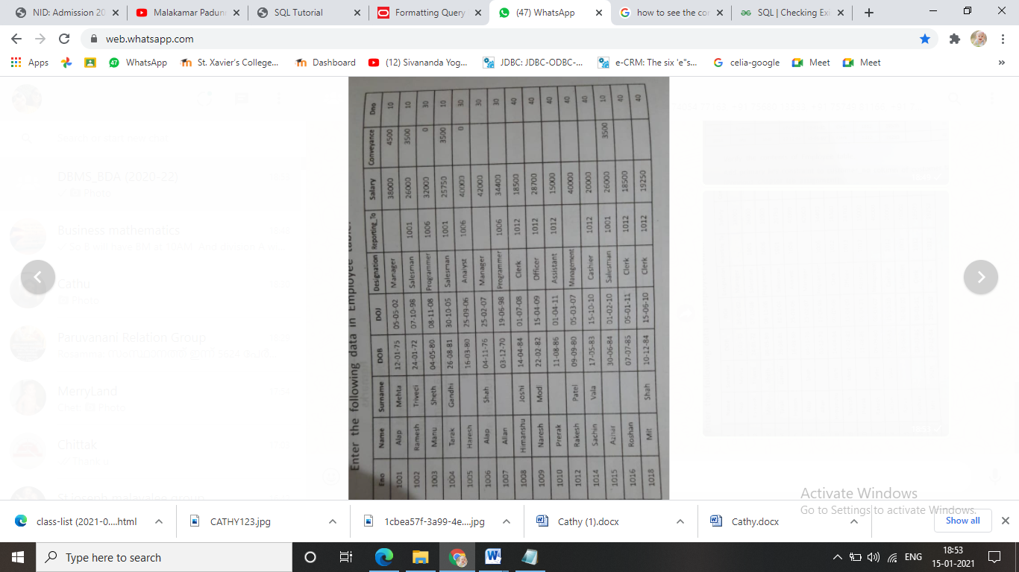
   2. 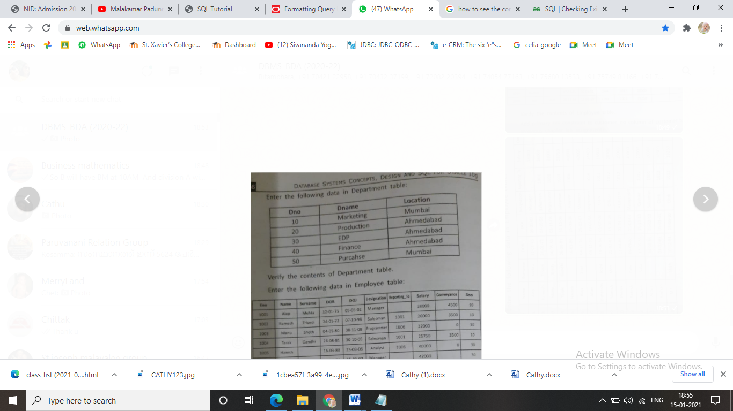
3. DISPLAY THE CONTENTS OF EMPLOYEE TABLE.
4. ADD EMAIL ID AND PHONE FIELD TO THE EMPLOYEE TABLE.
5. CHANGE THE DATA TYPE PF PHONE FIELD FROM NUMBER TO VARCHAR 10
6. ADD CONSTRAINT UNIQUE TO BOTH THE FIELDS.
7. REMOVE THE REPORTING FIELD FROM EMPLOYEE TABLE.
8. CHANGE THE NAME OF EMPLOYEE TABLE TO EMP_MASTER
9. LIST OUT THE CONSTARINTS GIVEN ON THE EMPLOYEE TABLE.
10. DELETE THE EARLIER CREATED STUDENT TABLE.
11. RENAME THE dno FIELD TO ‘DID’

19-1-2021

1. Display the employee daetails whose salary is above 10000 and belonging to did=30.
2. Display the employees who has joined in the time period of 2005 and 2010.
3. Display the employee details who having salary exactly 26000, 15250, 18000
4. Dispay the employee details of employees whose name begin with ‘r’ and end with ‘n’.
5. List the names of managers whose name ends with ‘p’.
6. Dispay the employee details of employees whose name begin with ‘r’ and end with ‘n and whose salary is above 15000
7. Display the employee name and salary including the commission.
8. Display the name of employee as the concatenation of name and surname.
9. Display the sum of salary and conveyance as total salary.
10. Create a new table employee from the existing table
11. Insert data from department table to dept table.
12. Update the salary by giving 10 percent increment
13. Change the designation of manager as senior manager
14. Delete the records having salary less than 15000
15. Remove the foreign key constraint
16. Add the foreign key constraint such as on deleting the records from parent table those values in child are set to null.
17. Sort the employee table using the name field in ascending ordrer